- Successfully installed python
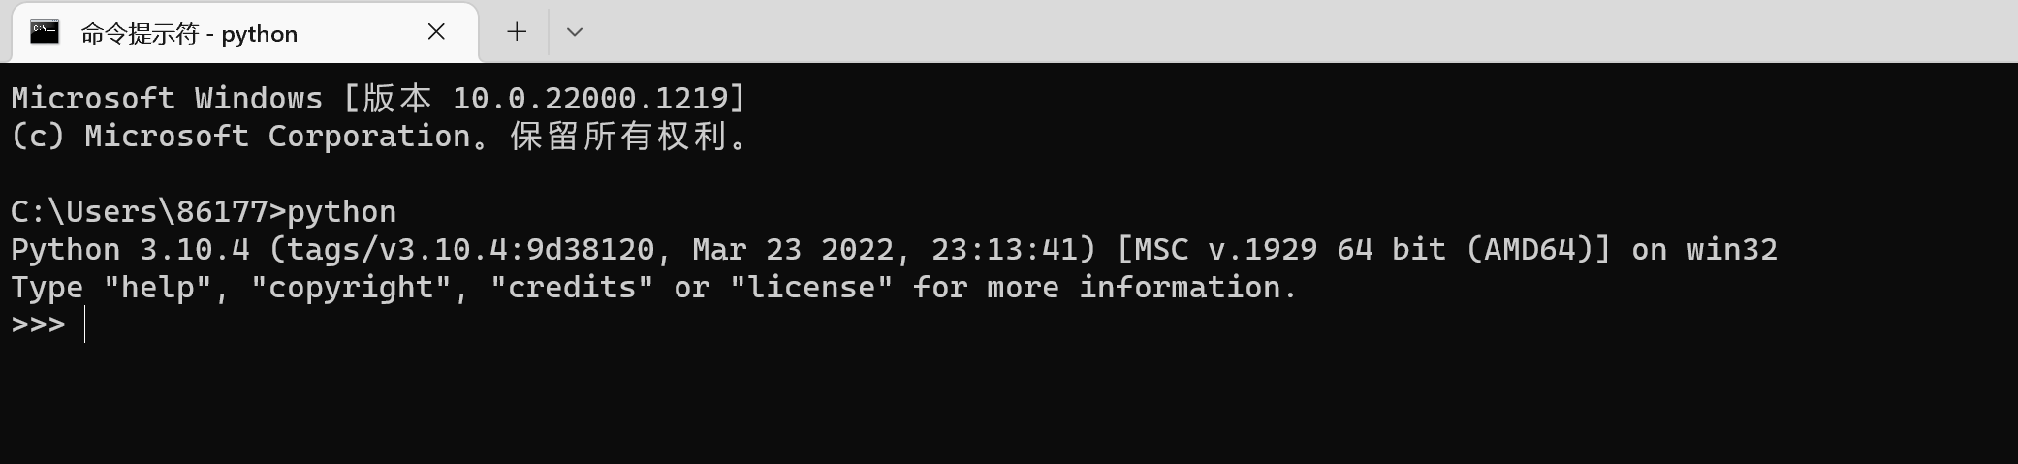

- Get some data
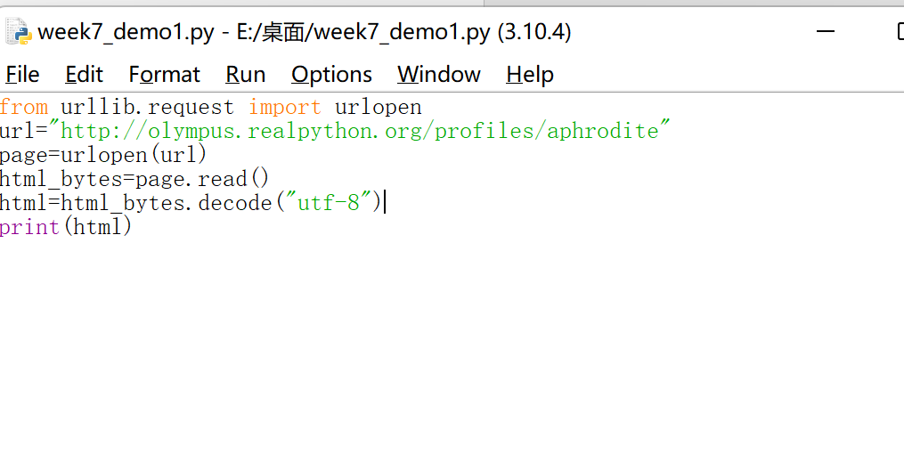
Result：
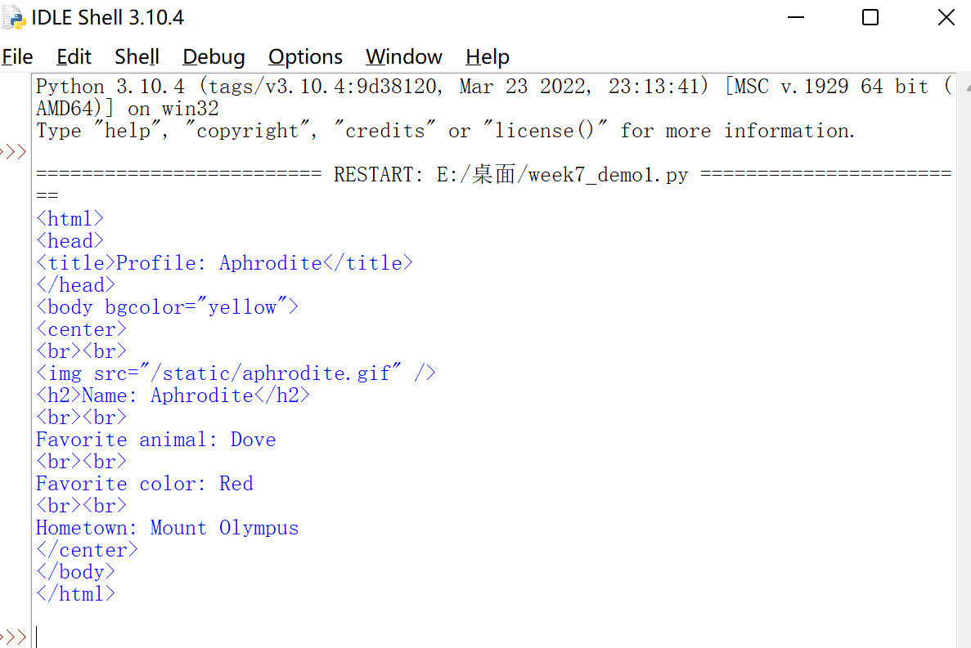

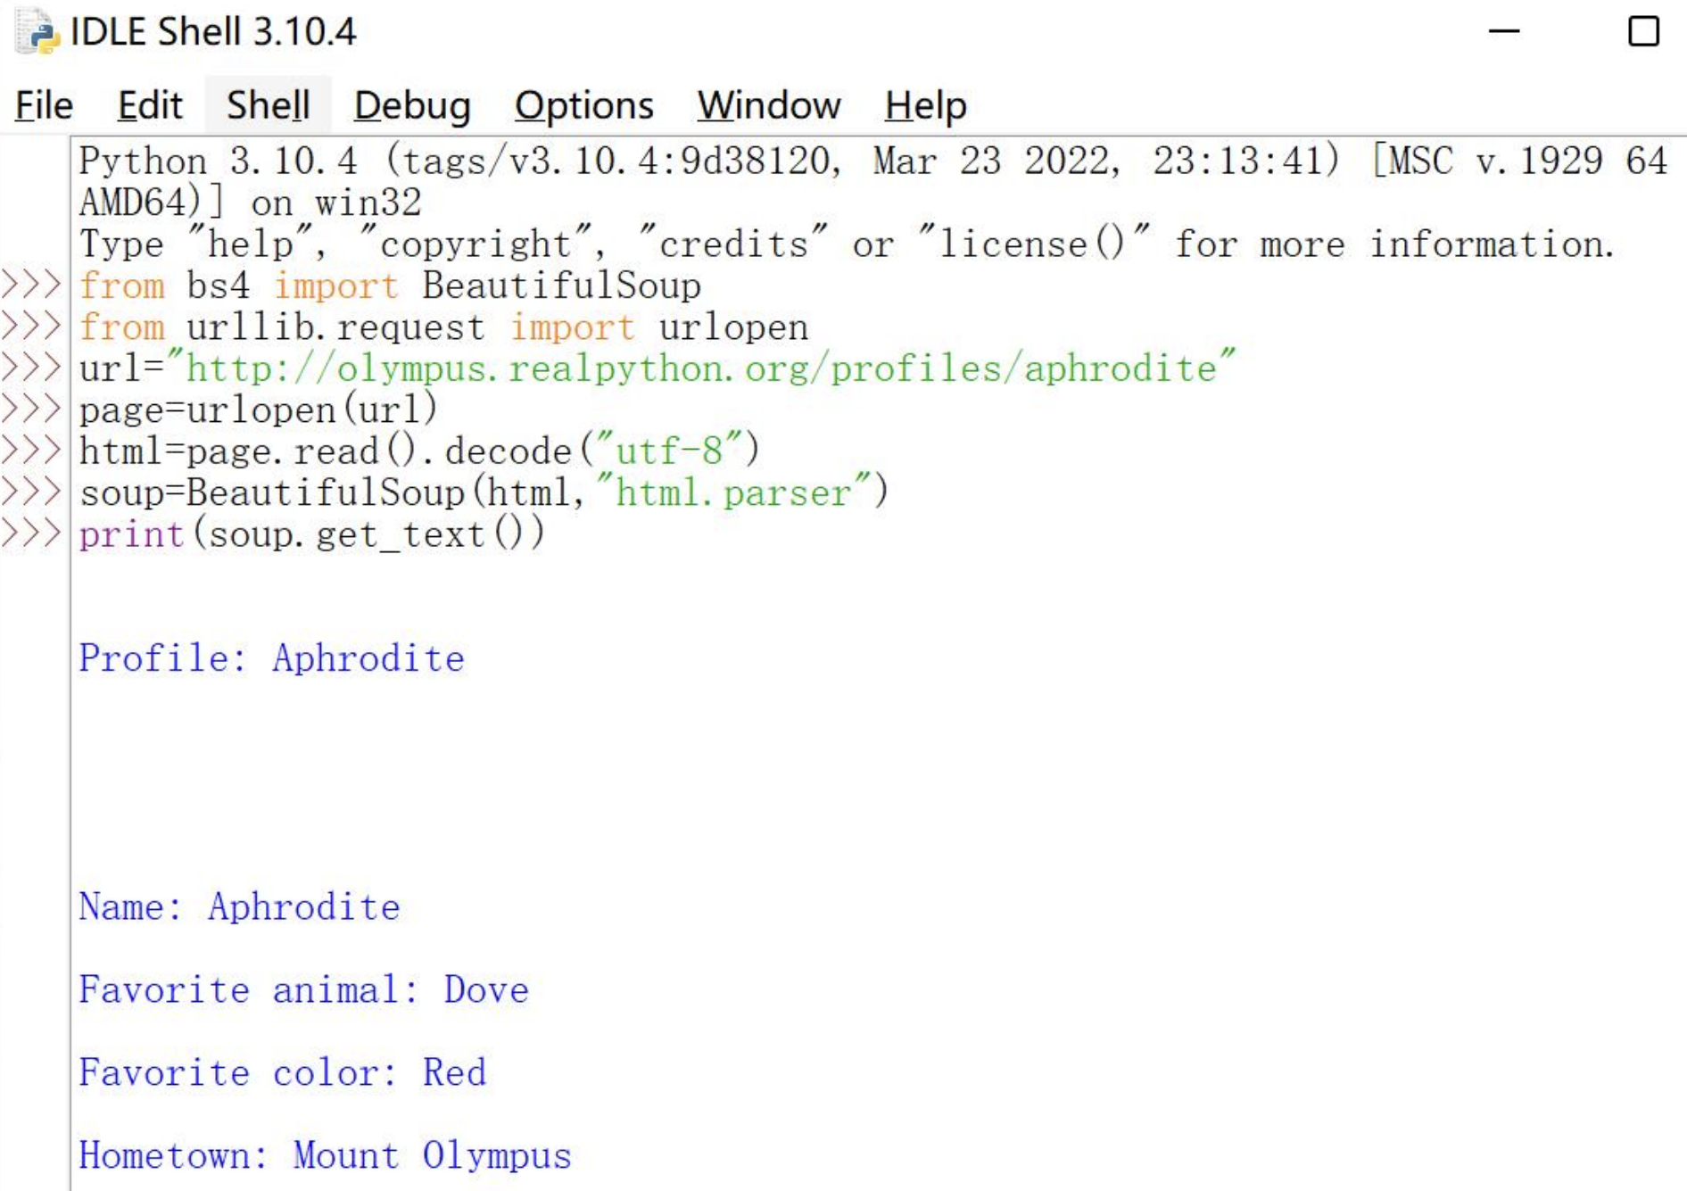

- Successfully installed BeautifulSoup

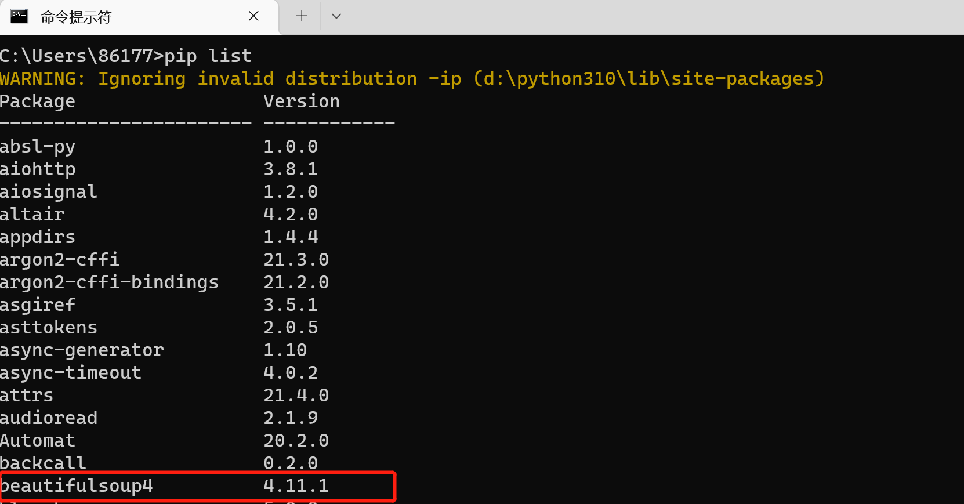

- using an editor to write Python scripts in separate files

Script for Reddit scraping:

from bs4 import BeautifulSoup
import csv
from urllib.request import urlopen
from urllib.request import Request

titles=[] #List to store post titles
upvotes=[] #List to store upvote value of a post
postcount=0
writecount = 0

url = "https://www.reddit.com/r/ProgrammingBuddies/"
req = Request(url, headers={'User-Agent': 'Mozilla/5.0'})
page = urlopen(req)

soup = BeautifulSoup(page, "html.parser")
for post in soup.find_all('div', attrs={'class':'Post'}):
title=post.find('h3')
upvote_block = post.find('div', attrs={'style':'color:#1A1A1B'})
titles.append(title.text)
upvotes.append(upvote_block.text)
postcount+=1

print(postcount) #optional, prints data to the console so you can check it
print(titles) #optional
print(upvotes) #optional

# open a csv file with append, so old data will not be erased
with open('reddit_posts.csv', 'w', newline='') as csv_file:
writer = csv.writer(csv_file)
for title in titles:
writer.writerow([title, upvotes[writecount]])
writecount+=1

output: The script has been run and the number of votes is correct.
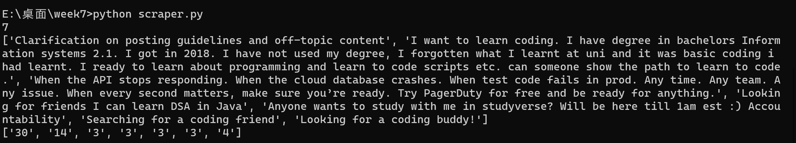

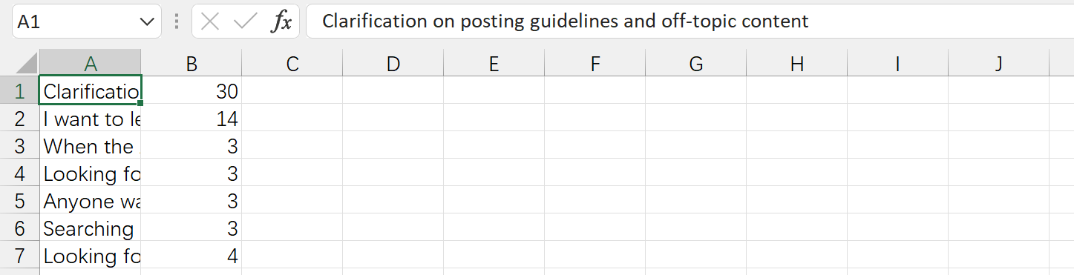

I have changed the URL and tag used in the above code to make it suitable for crawling any web page. Just identify the tags in the source code of the page and modify the code accordingly：

from bs4 import BeautifulSoup
import csv
from urllib.request import urlopen
from urllib.request import Request

titles=[] #List to store post titles
upvotes=[] #List to store upvote value of a post
postcount=0
writecount = 0

url = ""
req = Request(url, headers={'User-Agent': 'Mozilla/5.0'})
page = urlopen(req)
classname=""
style=""
loc=""

soup = BeautifulSoup(page, "html.parser")
for post in soup.find_all('div', attrs={'class':classname}):
title=post.find(loc)
upvote_block = post.find('div', attrs={'style':style})
titles.append(title.text)
upvotes.append(upvote_block.text)
postcount+=1

print(postcount) #optional, prints data to the console so you can check it
print(titles) #optional
print(upvotes) #optional

# open a csv file with append, so old data will not be erased
with open('your_scrapered.csv', 'w', newline='') as csv_file:
writer = csv.writer(csv_file)
for title in titles:
writer.writerow([title, upvotes[writecount]])
writecount+=1

