In week5, Using data in digital media
I downloaded an interesting online dataset Musician Digital Royalties PUBLIC 2013, adjusted some irrelevant columns and dealt with empty data, saved it in csv format, and then imported the dataset using PhpMyAdmin. Create a new database me21jx_week5, the data table is MusicData, and generate a PHP application program music.php. The link is as follows:

https://me21jx.leedsnewmedia.net/Assessment1_Portfolio/week5/music.php，
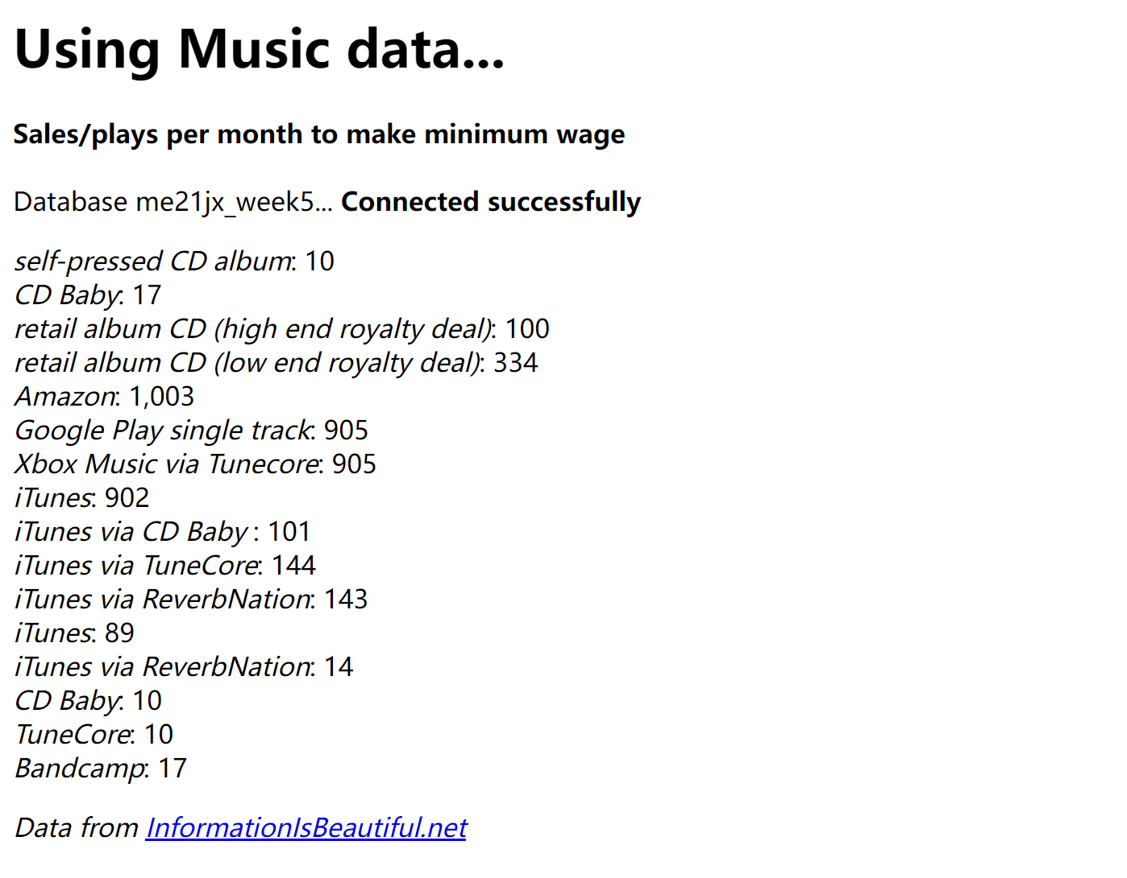
Through this code, the two columns of data in the data table MusicData in the database: Outlet, SALES are printed out. During the experiment, I also reported an error because I did not write the database table name correctly. But after the final success, the harvest is full, and the connection between php and phpmyadmin realizes the data display on the page, which is very intuitive.
Because there is already a database connected to the web page, then according to this principle, the code link is as follows:
Here is an example implementation for filling out a form.
https://me21jx.leedsnewmedia.net/Assessment1_Portfolio/week5/music2_Example1.php
Here is an example implementation of select data.
https://me21jx.leedsnewmedia.net/Assessment1_Portfolio/week5/music2_Example2.php
Finally, according to the guidelines of the third pdf: use a graphics library to draw pictures, I drew two graphs: the links are as follows:
https://me21jx.leedsnewmedia.net/Assessment1_Portfolio/week5/music3_line_graph.php
https://me21jx.leedsnewmedia.net/Assessment1_Portfolio/week5/music3_graph.php
I have a deep understanding of the role of the graphics library and the role of canvas, and this week's programming has gained a lot.

